# SYD366 Assignment - Individual Component

Luca Novello | Dec 1, 2024

## Introduction:

For the additional functionality to Victoria’s *Breadboard Bakery* website, I chose to add a “*Repeat Last Order*” function that allows the customer to place a new order with the same items from their previous. This can be useful for customers that make repeat orders and could help users streamline customer order process.

## Use Case:

|  |  |
| --- | --- |
| Use Case Name | Repeat Previous Order |
| Brief Description | Allows the user to repeat the last order they placed |
| Triggering Event | User wishes to place a new order like their previous order |
| Actor(s) | User |
| Related Use Cases | Cancel Order, Edit Order |
| Pre-Conditions | The user has opened the website, and a previous order has been placed. Note: the user needs to be logged in. |
| Post Conditions | The order is placed and is viewable by both the user and the owner. |
| Exception Conditions | User opts to cancel creating the repeat order. |
| Flow of Activities | |
| User | System |
| 1. Clicks “Place Order” button. | * Directs user to the “Place an Order” page. * Search Orders for user_Id and return most recent. * [If previous Order exists] Show option to “Repeat Last Order”. * Displays options for placing an order. |
| 1. Clicks “Repeat Last Order” button. | * Populate new order with order details from last order. * [If Order type is “Catering”] Displays drop-down list of baked goods. |
| 1. [Begin Loop] Selects additional baked goods. | * The user will select baked goods from the drop-down list and the list will populate with the selections. * The user can also edit the number of any baked goods ordered in the populated list. |
| 1. Enters desired information. | * Validates user’s information. * Highlights any fields which are not filled in correctly. * Prompts user to select from the drop-down list again or confirm order. |
| 1. [End Loop] Confirms contents of order. | * Display fields for order information, which are: date of delivery, address of delivery and billing information. |
| 1. Displays delivery and billing information. | * Requests for user to confirm. |
| 1. User confirms order. | * The order is placed. * User is directed to an order confirmation screen which lists all the details of their order and the receipt. |

## Class Diagram:

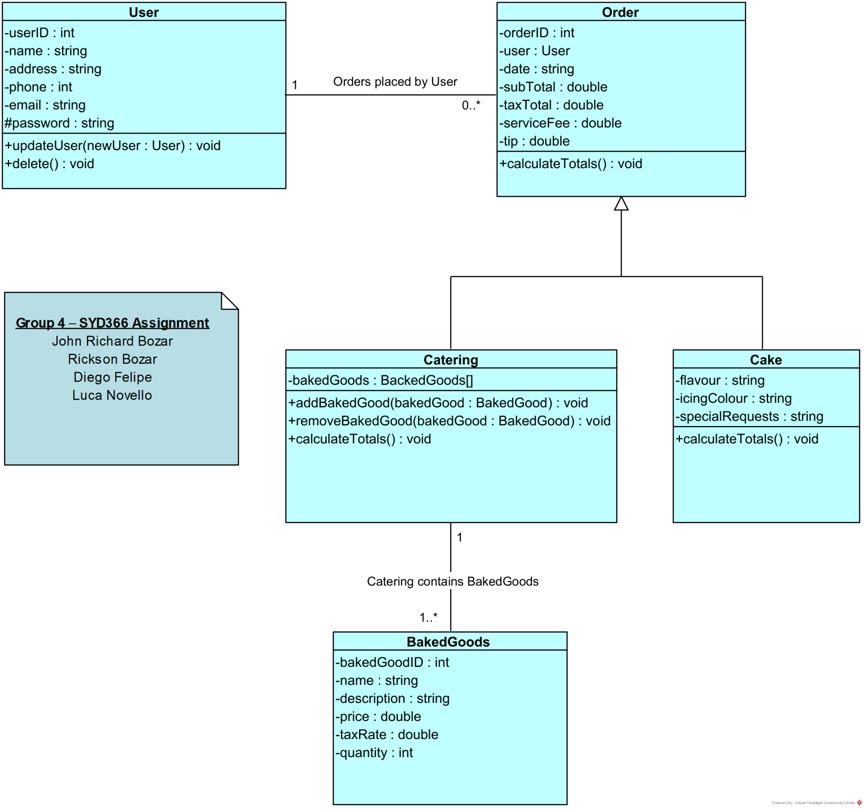

## Controller Classes:

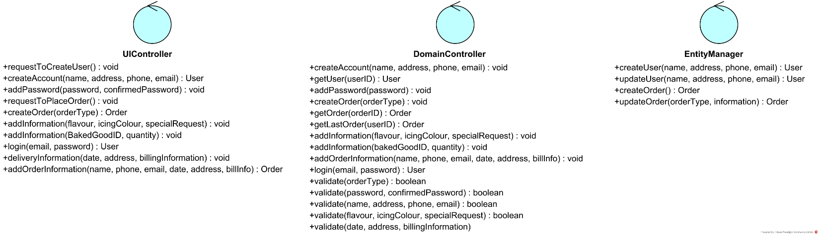

## Sequence Diagram - Repeat Previous Order:

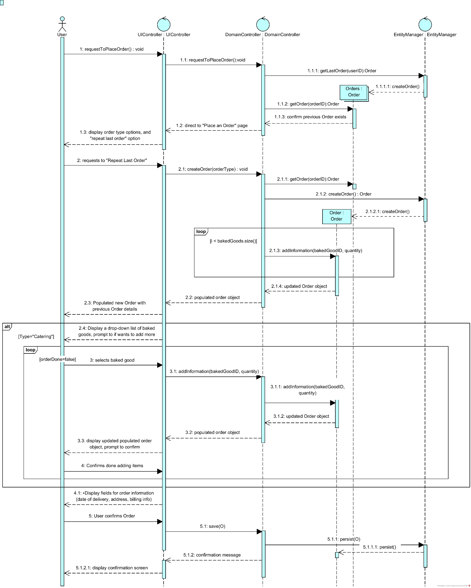

## Wireframe – Repeat Previous Order:

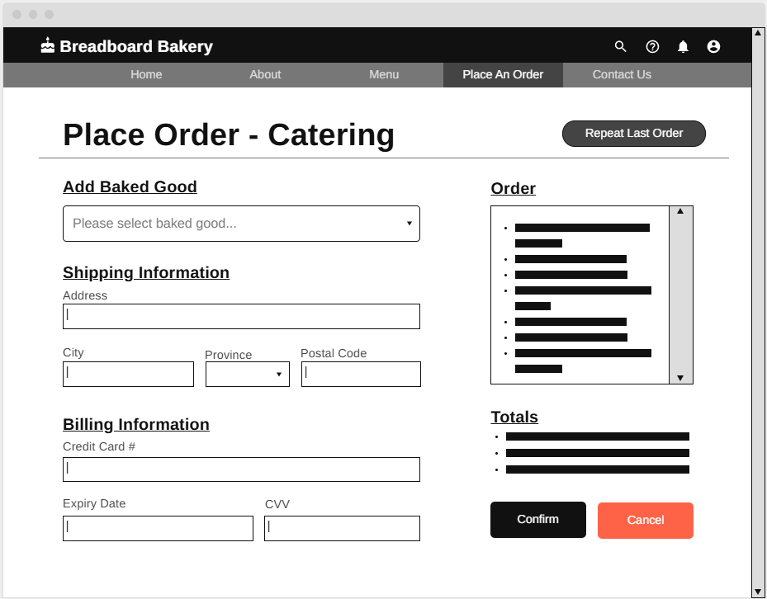

Menu: Account Information and navigation.

Order Main Section:

* Repeat Previous Order button
* Form to enter details such as:
  + List of Baked Goods
  + List of Baked Goods add to Order
  + Shipping Information
  + Billing Information
  + Totals
  + Confirmation and Cancel button